**Problem statement:** Analyzing changes in signal data occur due to multipath effects in both indoor and outdoor environments.

The main objectives are as follows:

1. To provide a continuous processing system (CPS) by using Spark SQL engine for structural streaming data.
2. To identify new changes in time series that occurs for streaming data.

**Reported outcomes:** A survey of related works in change detection for time series for signal data and implemented to plot the datasets by using python packages.

**Specific Aims:**

1. Downloaded and installed anaconda for implementation.
2. Jupyter notebook has been launched and relevant packages are installed for data exploration analysis.
3. Gather all related papers and categorize them.

**Key Accomplishments:**

1. Loaded the BLE Dataset by using Pandas DataFrame library in python.
2. Implemented the plots for BLE Dataset by using matplotlib library in python.

**Red Flags:**

1. We are not handling streaming data.
2. We are not data-driven.

**Future Work:**

1. To implement CPS by using sparkSQL for streaming data in python by installing pyspark package in jupyter notebook.

**Timeline (tentative timeline for the upcoming week)**

|  |  |  |  |  |  |  |
| --- | --- | --- | --- | --- | --- | --- |
| **Future Specific aims** | **09/25** | **09/26** | **09/27** | **09/30** | **10/01** | **10/02** |
| Implementation of streaming data framework by using apache spark |  |  |  |  |  |  |
| Preprocessing of data |  |  |  |  |  |  |
| Implementation of change detection based on parametric approaches |  |  |  |  |  |  |

**References:**

[1] S. Aminikhanghahi and D. J. Cook, “A survey of methods for time series change point detection,” *Knowledge and Information Systems*, vol. 51, no. 2, pp. 339–367, Aug. 2016.

[2] A. Bifet, G. Holmes, and B. Pfahringer, “MOA-TweetReader: Real-Time Analysis in Twitter Streaming Data,” *Discovery Science Lecture Notes in Computer Science*, pp. 46–60, 2011.

[3] “Analysis of real-time data with spark streaming,” *Journal of Advances in Technology and Engineering Research*, vol. 3, no. 4, 2017.

**Appendix A**

**Results**

**Loading the BLE dataset in Jupyter Notebook:** 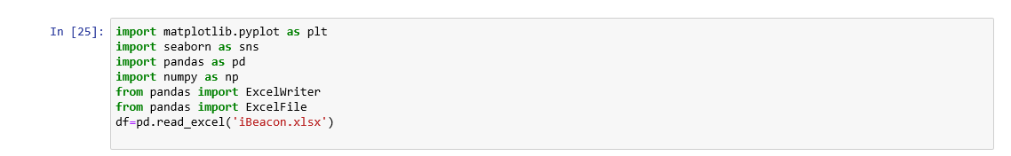

**Exploration Analysis:**

